Tab 1

QP Pattern - END Sem

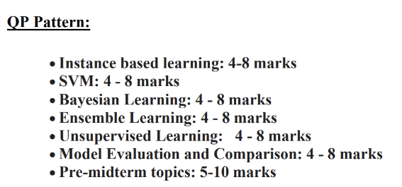

LECTURE 1 - INTRO

MidSem 2023-24 Makeup
Q1. a) For the scenarios given below, answer the following questions:
1) Which machine technique(s) is/are suitable for the cases given below? (1 marks)
2) Why? Justify your choice. (2 marks)

Scenarios
A) A hospital wants to develop a system to assist doctors in diagnosing a specific medical
condition based on patient data.

Ans - [Supervised L, Classification, target variable is discrete in this case]

B) Given data on how 1000 medical patients respond to an experimental drug (such as effectiveness of the treatment, side effects, etc.), discover whether there are different categories or "types" of patients in terms of how they respond to the drug, and is if so, what these categories are.

Ans -[Unsupervised L, Clustering, categories not given]

Q1. b) If your model performs great on the training data but generalizes poorly to unseen instances, what could be the possible reason for this? Can you suggest any 2 possible solutions to solve this problem? [2]

Ans - Overfitting
Solutions: More Training data, Simplifying the model (reducing the number of features used, or
regularizing the model), reducing the noise in the training data

Q1.c) A Google machine learning system beat a human Go player in 2015. This complicated game may contain more playable options than there are universe atoms. The first version won by observing hundreds of thousands of hours of human game play; the second version learnt by getting rewards while playing against itself. How would you describe this transition to different machine learning approaches? [2]

Ans - The system went from supervised learning to reinforcement learning. The first version is supervised learning and second is reinforcement learning.
EndSem 2024-25 Regular

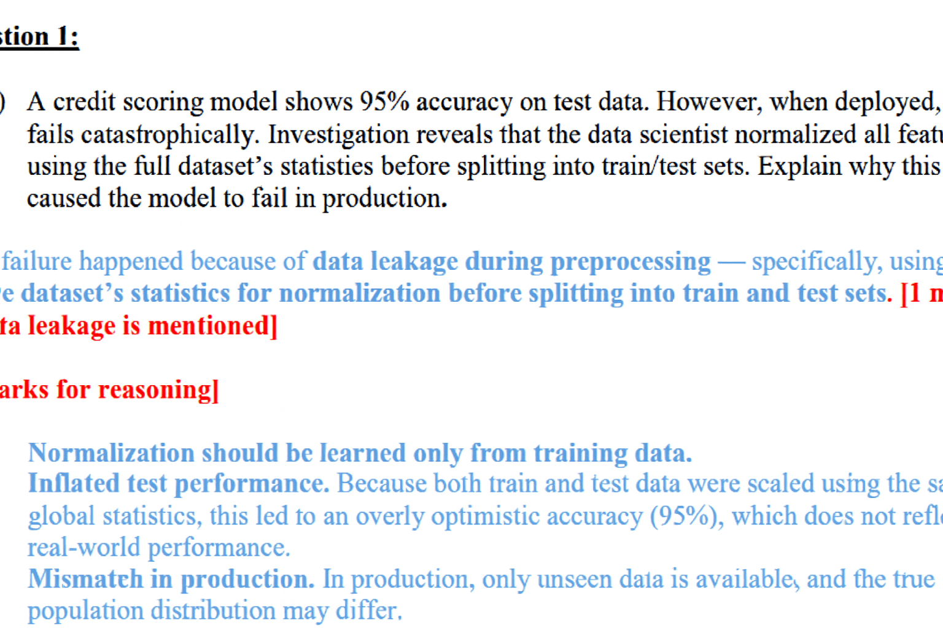
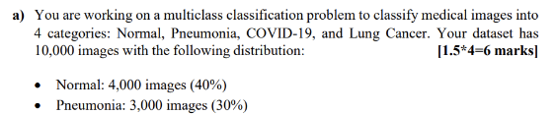
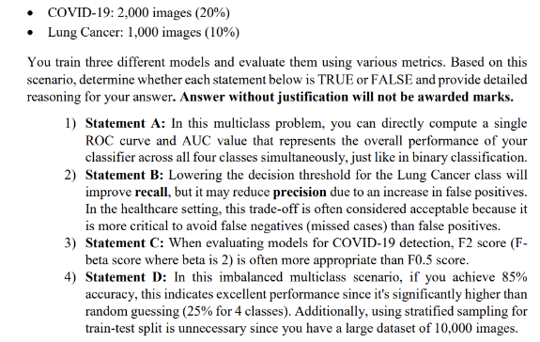

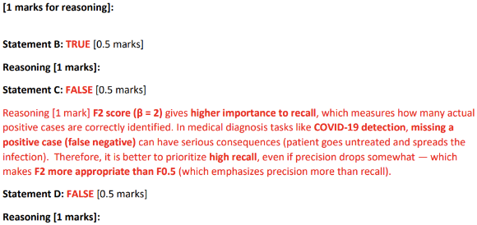
EndSem 2024-25 Regular
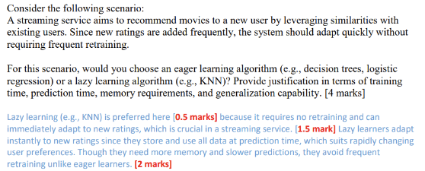
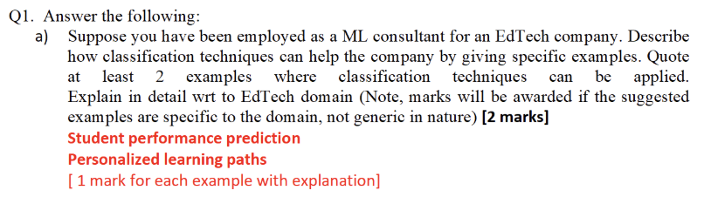
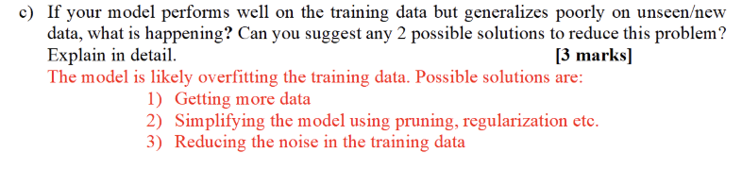

LECTURE 2 - DATA
MidSem 2023-24 Regular
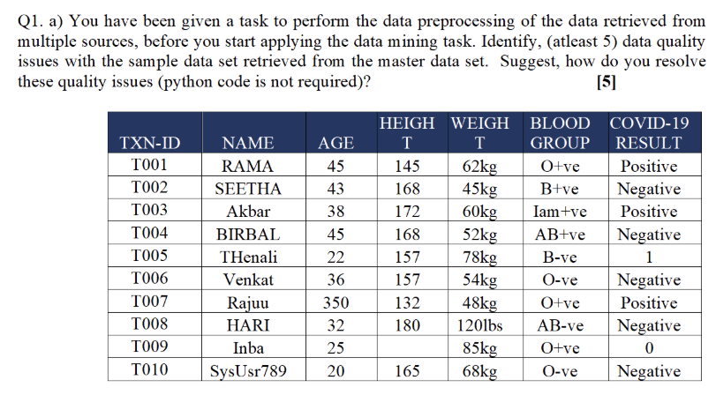
Ans -
- The attribute value SysUsr789 for the Name in the given data (T010 record) is not consistent with other names and it has alpha numeric when compared with other data types. (0.5)
This data quality issue can be resolved by replacing that field with right name/data type for consistency. ( 0.5)
- The Age 350 is the outlier in T007 record and Height for Inba is missing (T009) (0.5)
These data issues can be resolved by filling the mean value of age and height. (0.5)
- There is a mismatch in the data type units in T008, the Weight Unit for Hari is 1201bs whereas all other attributes are having Kg values. (0.5)
This is the data type issue and it can be done through data transformation by either manual or automatic edits of erroneous data (0.5)
- The blood group has different representation in T004 record, inconsistent format of Iam+ve is being used in the blood group. (0.5)
This can be replaced with either NULL or by applying binning techniques (0.5)
- Transaction id T005 has Covid Result-Representation Mismatch as 1 and in T009 it has 0, instead of indicating positive and negative values (0.5).
This data quality issue can be solved by applying data transformation such as data smoothing to make the simple changes as there are only two values which requires replacement. (0.5)

MidSem 2023-24 Regular
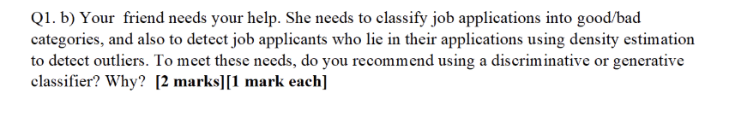
Ans - Generative classifier . Reason - for density estimation you should calculate P(x|y)

EndSem 2024-25 Regular
Question 1:

a) A credit scoring model shows 95% accuracy on test data. However, when deployed, it
fails catastrophically. Investigation reveals that the data scientist normalized all features
using the full dataset's statistics before splitting into train/test sets. Explain why this
caused the model to fail in production.

This failure happened because of data leakage during preprocessing - specifically, using the
entire dataset's statistics for normalization before splitting into train and test sets. [1 mark
if data leakage is mentioned]

[2 marks for reasoning]

. Normalization should be learned only from training data.
· Inflated test performance. Because both train and test data were scaled using the same
global statistics, this led to an overly optimistic accuracy (95%), which does not reflect
real-world performance.
. Mismatch in production. In production, only unseen data is available, and the true
population distribution may differ.

LECTURE 3 - Linear Regression
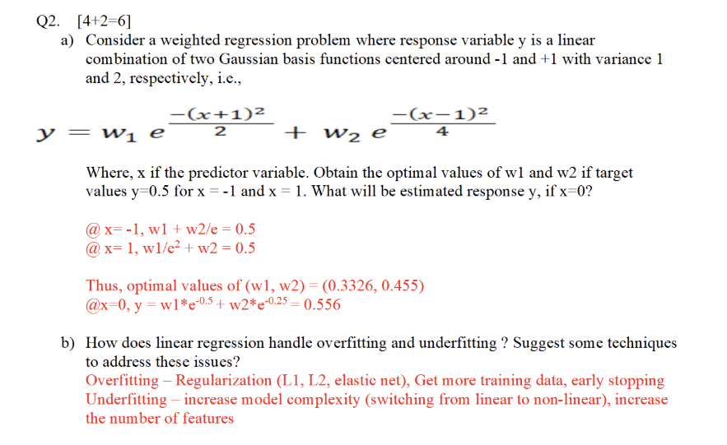
EndSem 2022-23
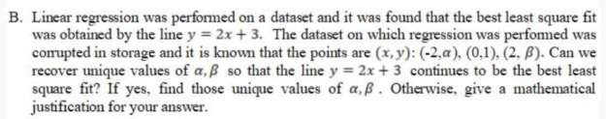

MidSem 2023-24 Makeup
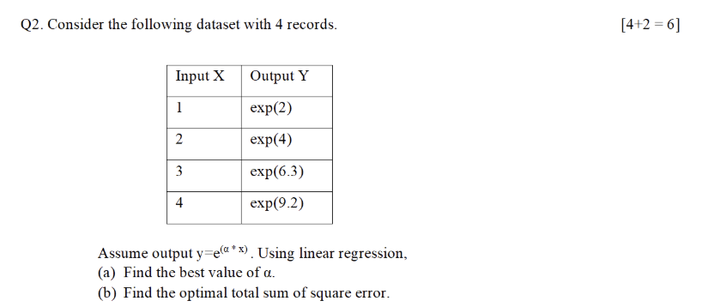
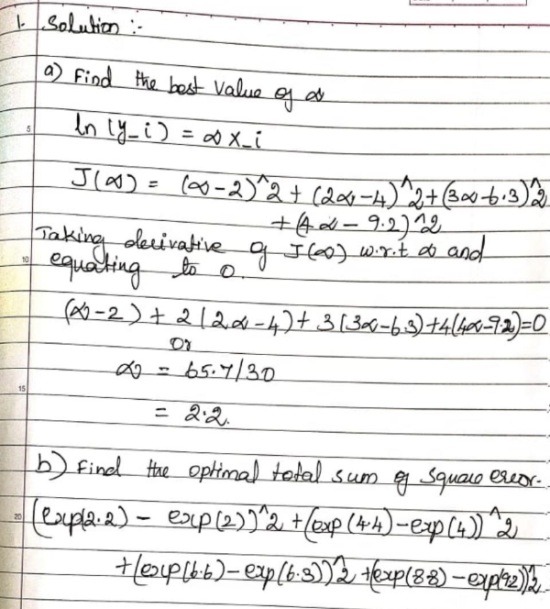

MidSem 2023-24 Regular
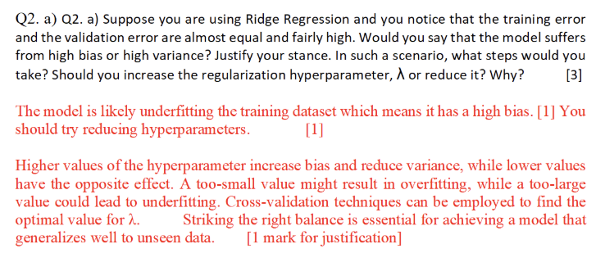
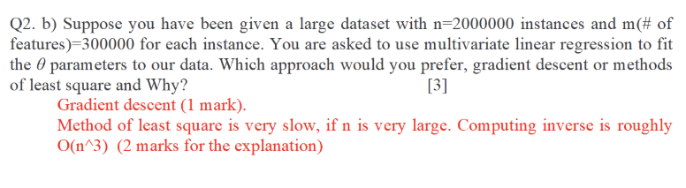

LECTURE 4 - Logistic Regression
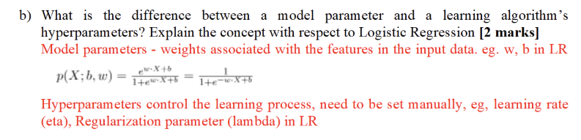
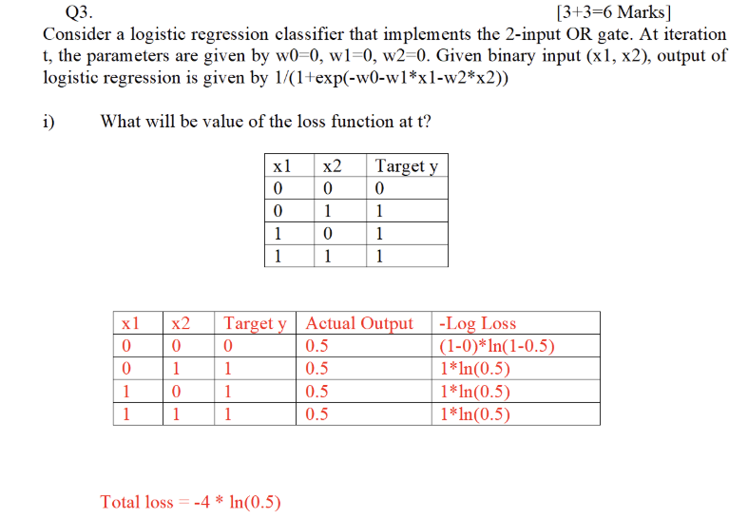
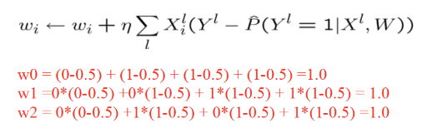
EndSem 2022-23
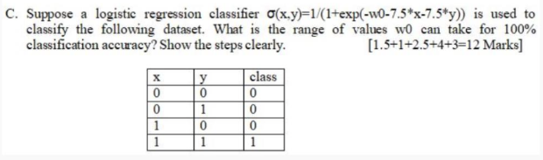

MidSem 2022-23
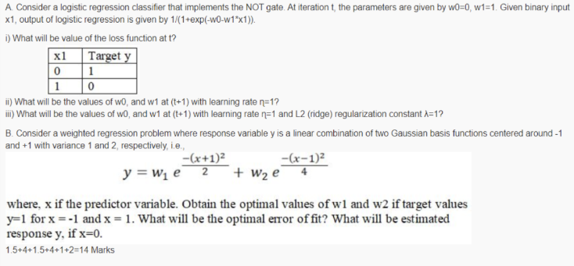

EndSem 2023-24 Makeup
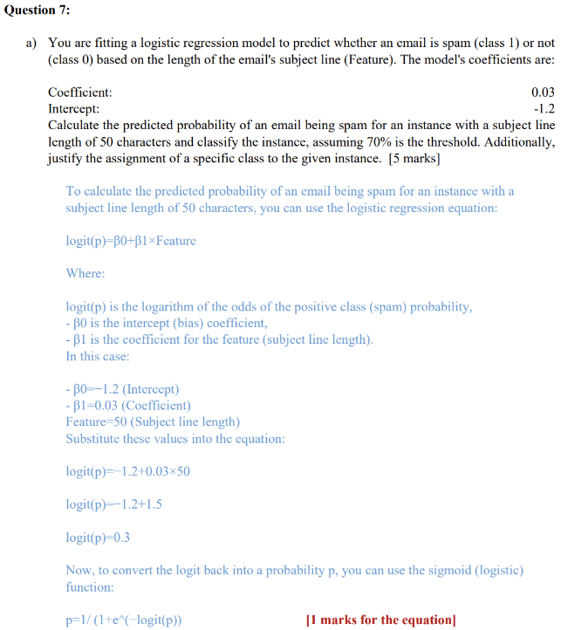
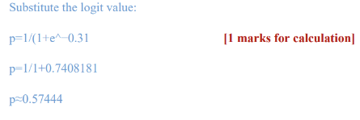
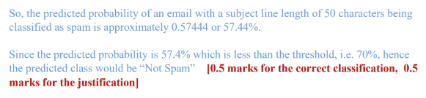

MidSem 2023-24 Regular
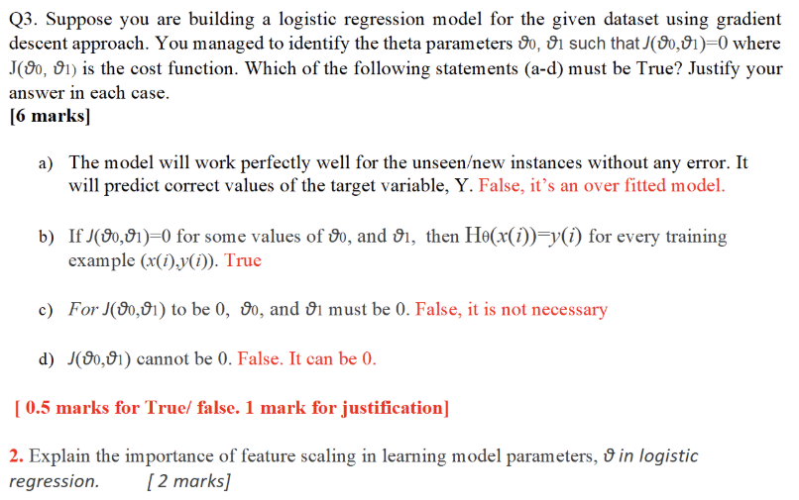

EndSem 2023-24 Regular
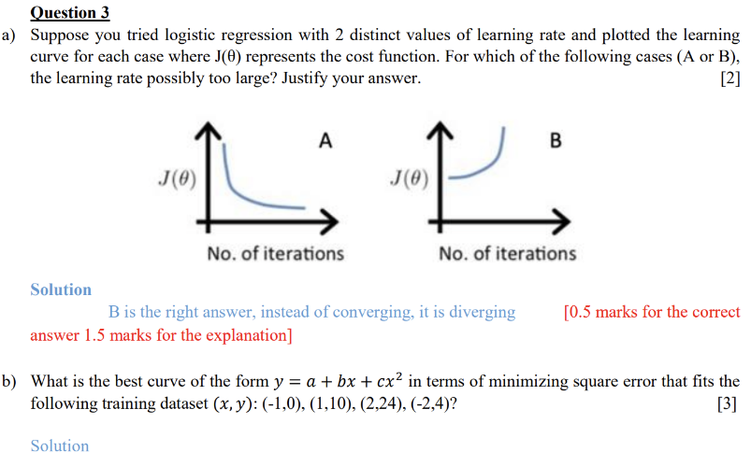
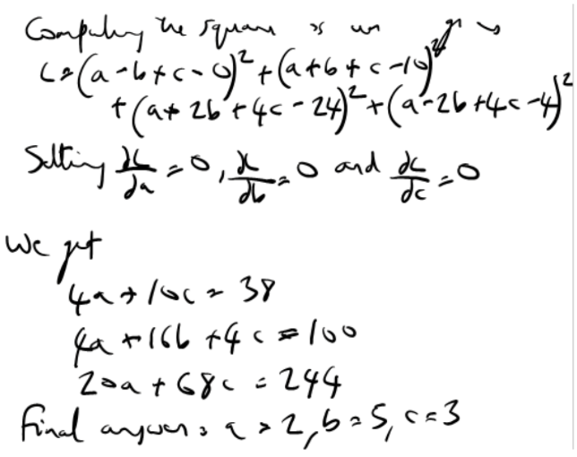

LECTURE - Classification
EndSem 2022-23
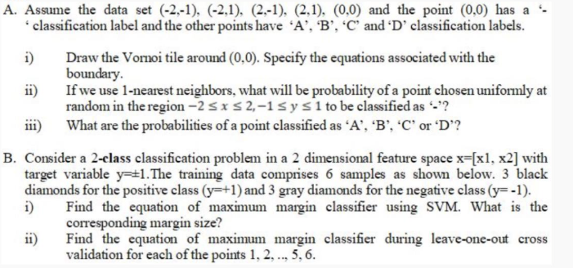
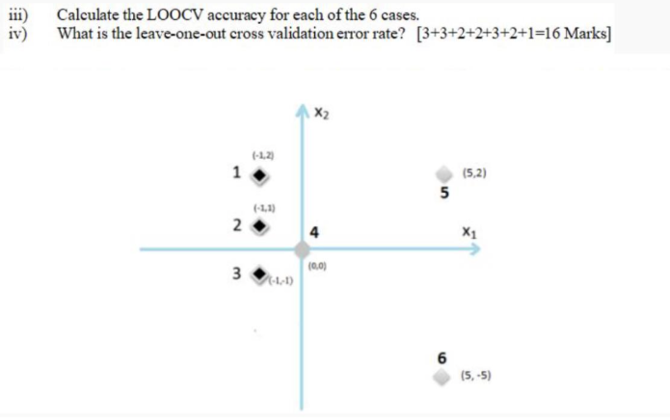

MidSem 2022-23
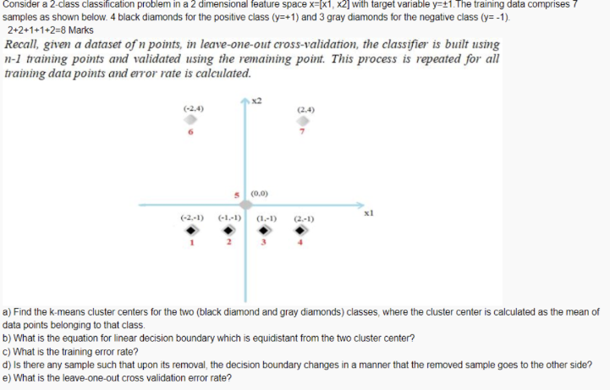

MidSem 2023-24 Makeup
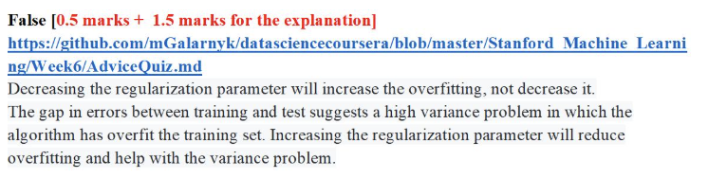

MidSem 2023-24 Makeup
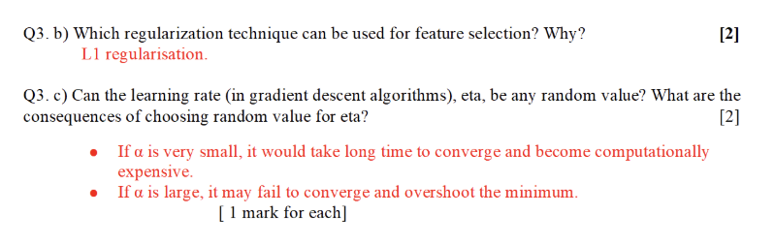

MidSem 2023-24 Makeup
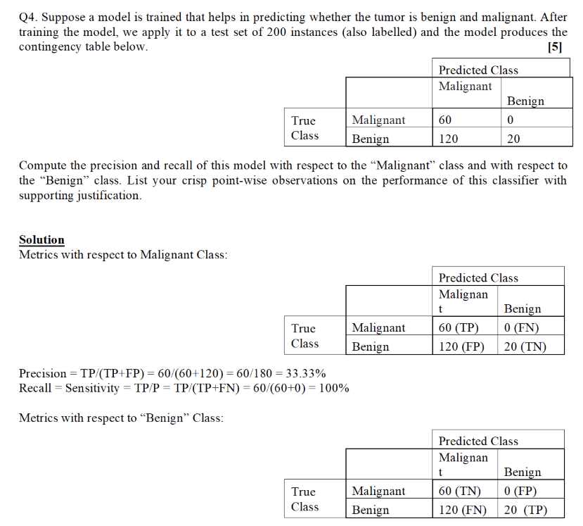
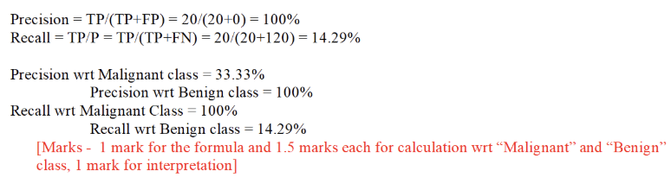
MidSem 2023-24 Regular
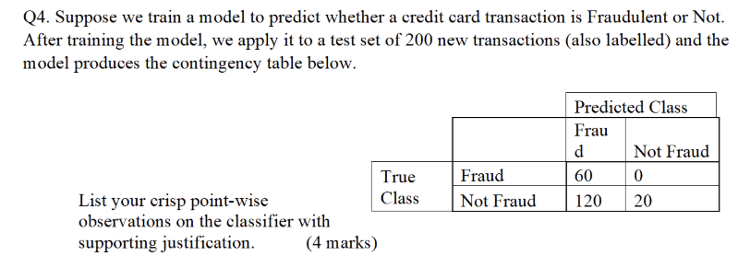

EndSem 2023-24 Makeup
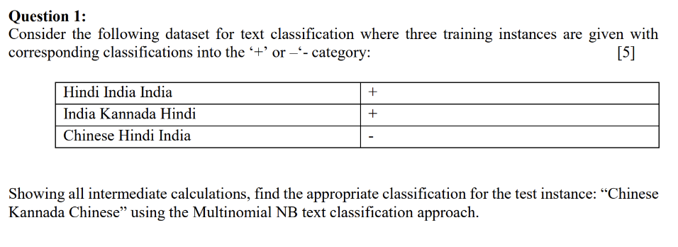
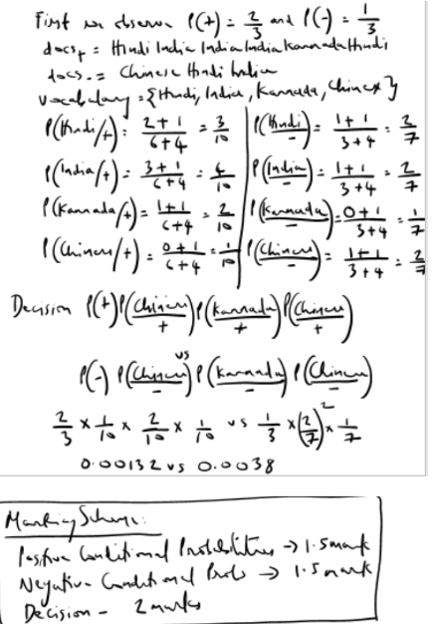
EndSem 2023-24 Regular
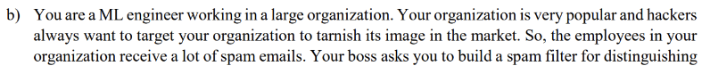
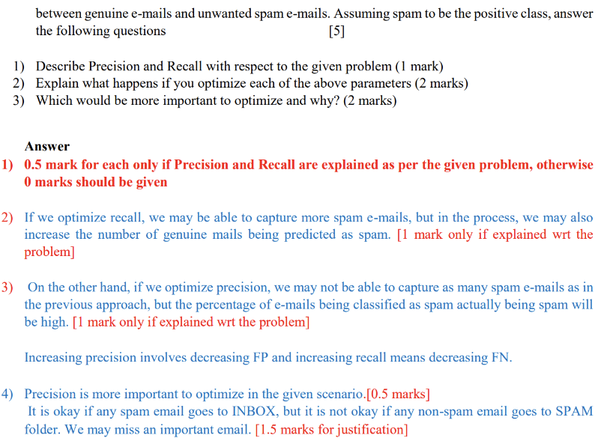

EndSem 2024-25 Regular
Question 2:
You are developing a classifier to categorize chest X-ray images into four classes: Normal,
Pneumonia, COVID-19, and Lung Cancer. Since Lung Cancer is a rare condition in your
dataset (only about 10% of the images), your priority is to minimize the risk of missing any
potential Lung Cancer cases. To achieve this, you consider adjusting the decision threshold for
the Lung Cancer class in your model. If you adjust the decision threshold to optimize recall for
rare classes (like Lung Cancer), what trade-off might you expect with precision? Why is this
trade-off acceptable or unacceptable in a healthcare setting? [3 marks]
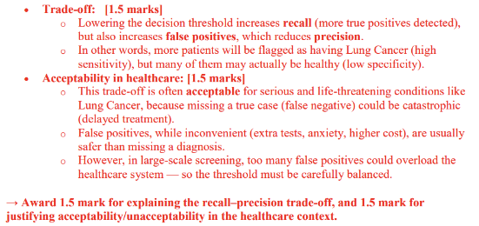
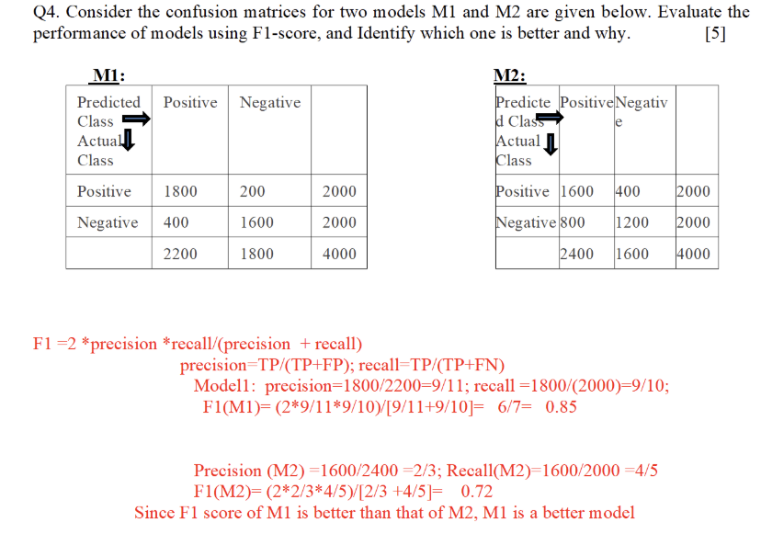
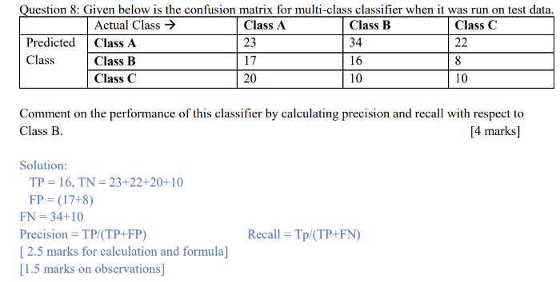

LECTURE - Probability Naive Bayes
EndSem 2022-23
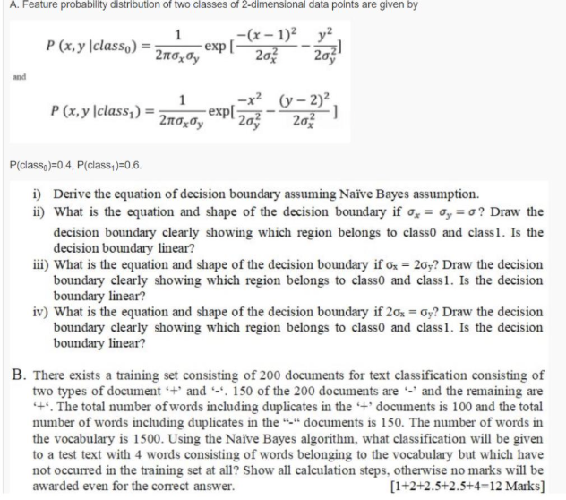

EndSem 2024-25 Makeup
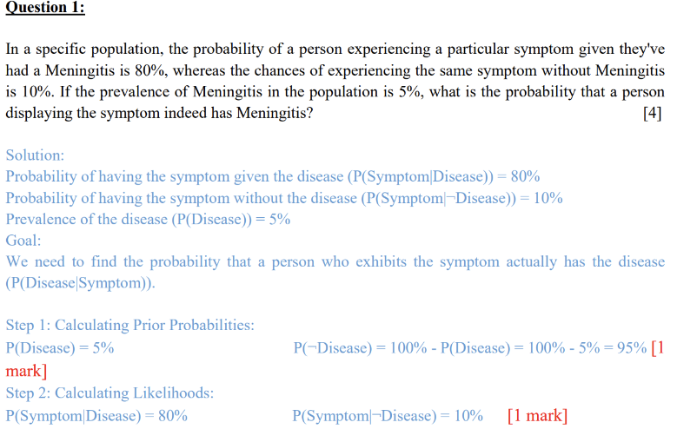
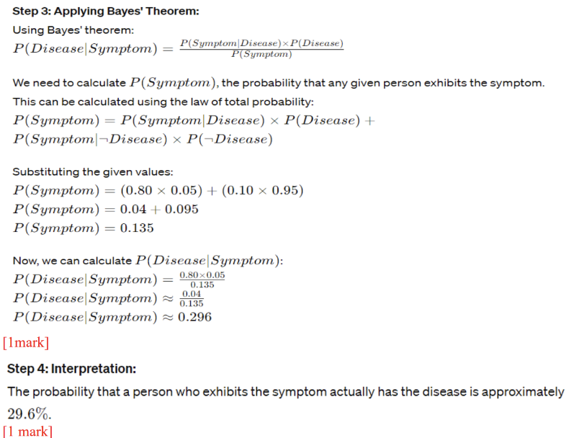

EndSem 2024-25 Makeup
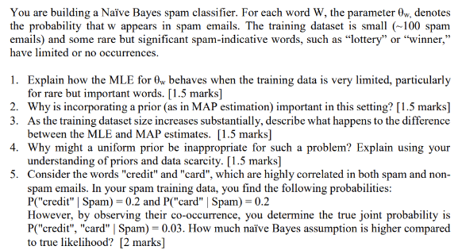
Solution:
1. MLE relies solely on observed data; rare words not observed lead to (thetha w) Ow=0 ignoring their
spam relevance and causing zero-probability problems. [1.5]
2. MAP incorporates prior knowledge that certain words are likely spam indicators,
preventing zero estimates by smoothing and incorporating beliefs, which improves
robustness with sparse data.
3. With increasing data, the data likelihood dominates the prior, making MAP and MLE
estimates converge. Priors matter less as evidence from ample data accumulates.
4. Uniform priors treat all words equally a priori, ignoring domain knowledge on rare but
important words, diluting key signals and leading to suboptimal classification in limited
data regimes.
5. Naïve Bayes Likelihood (independence assumption) :
P_naive("credit", "card" | Spam)
=P("credit" | Spam) * P("card" | Spam)
= 0.2 * 0.2 = 0.04 [1 mark]
True Likelihood: P_true("credit", "card" | Spam)= 0.03
Naïve Bayes model's estimate (0.04) is higher than the true value (0.03) by 0.01 [1 mark]
EndSem 2024-25 Regular
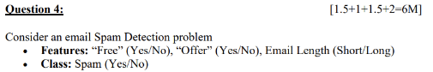
Feature / Class | Spam | Not Spam
Free = Yes | 40 | 5
Free = No  Offer = Yes  Offer = No | 20  30  30 | 45  10  40
Length = Short  Length = Long | 50  10 | 20  30
Total emails | 60 | 50

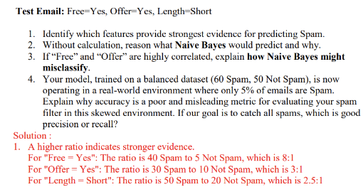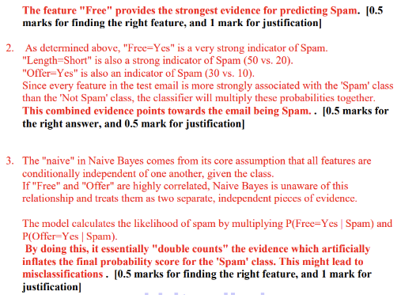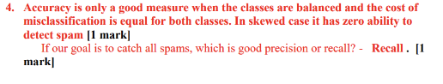
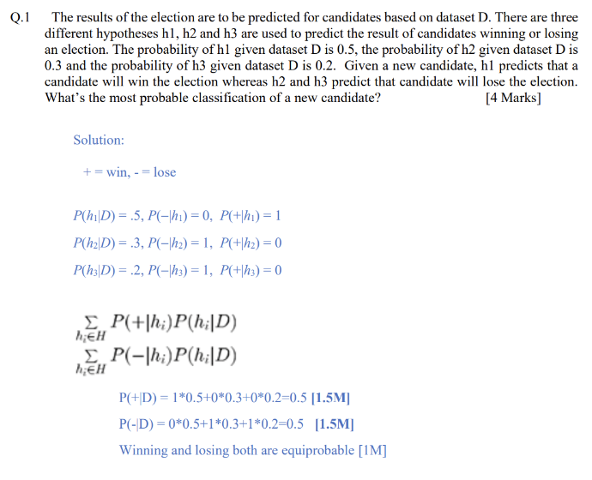

LECTURE - Decision Tree
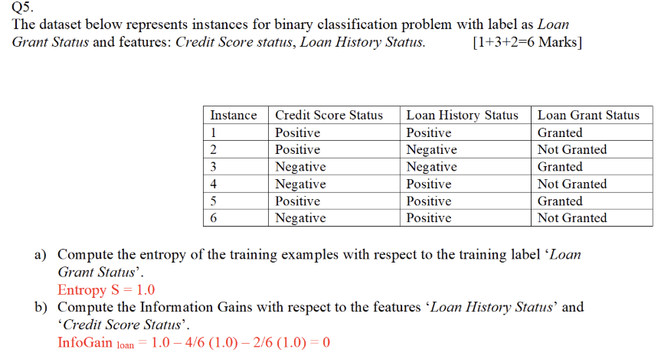
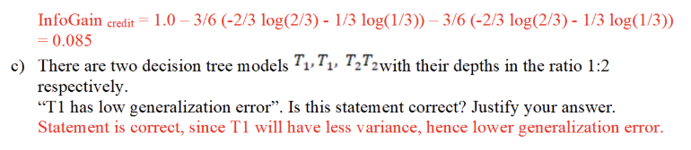
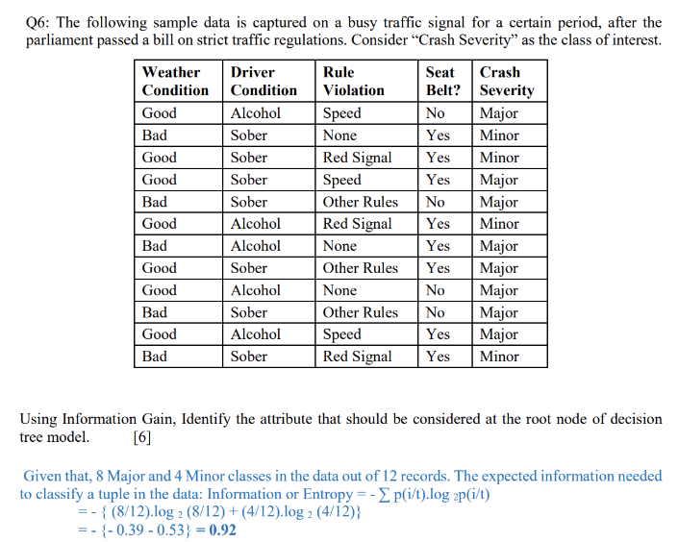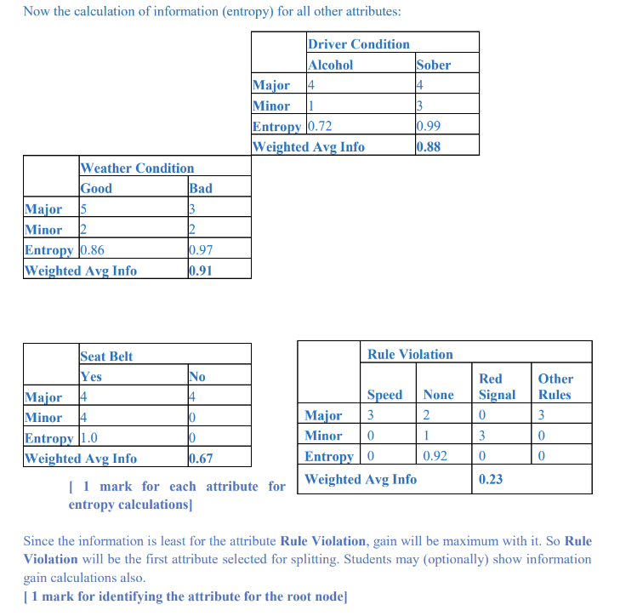
MidSem 2022-23
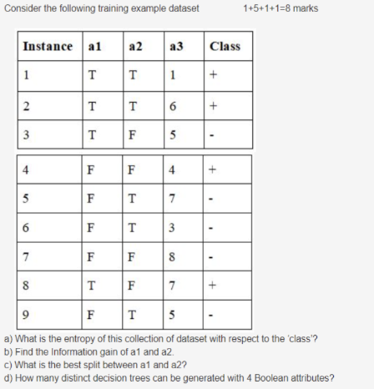

MidSem 2023-24 Makeup
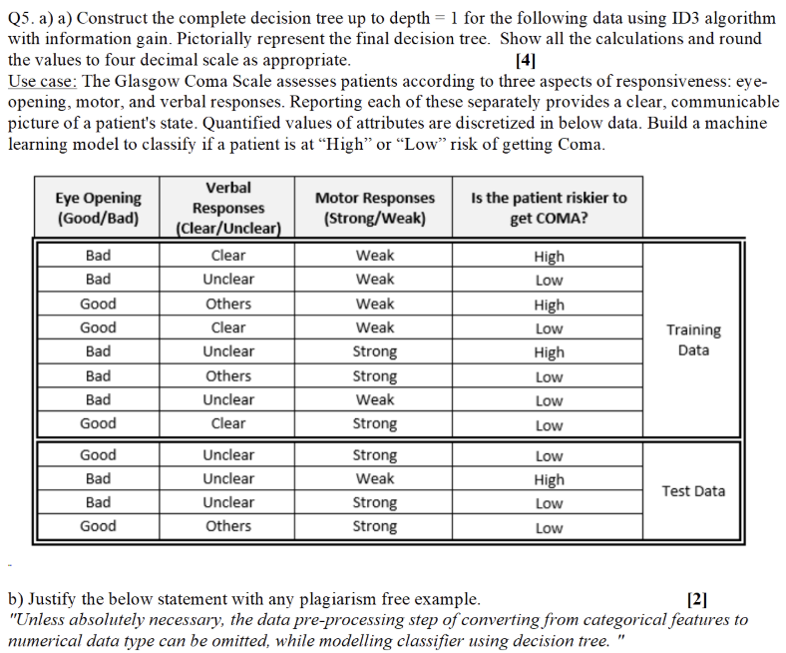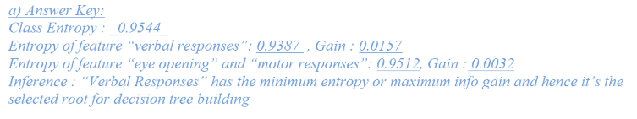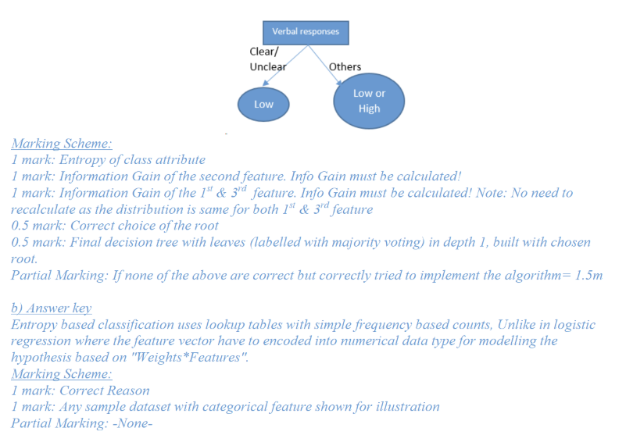
MidSem 2023-24 Regular
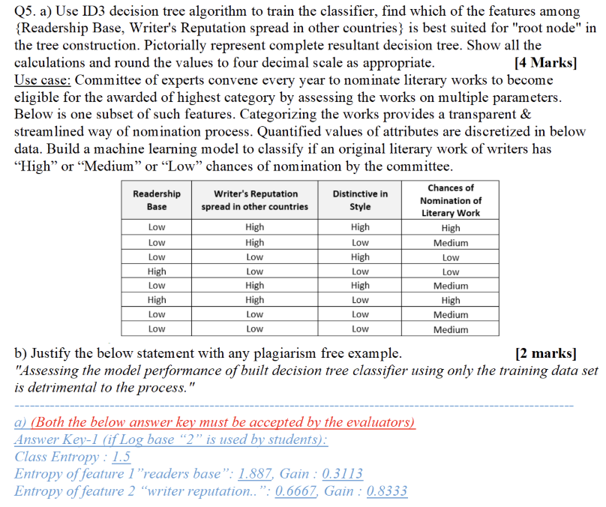
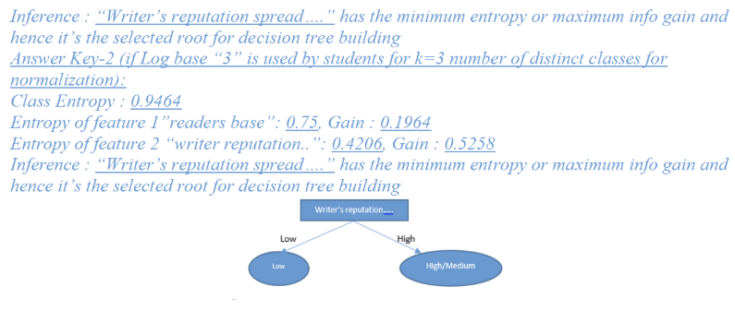
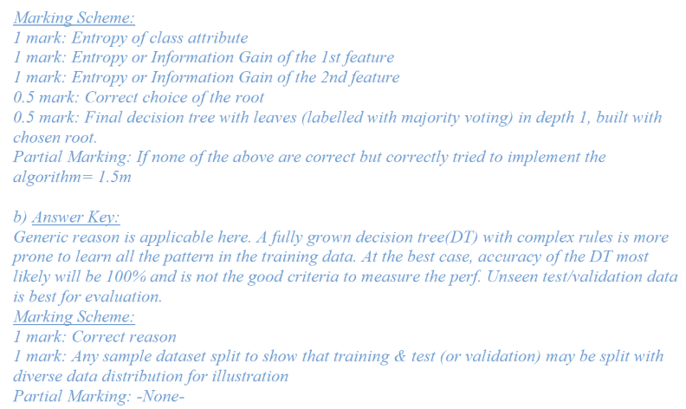
EndSem 2023-24 Makeup
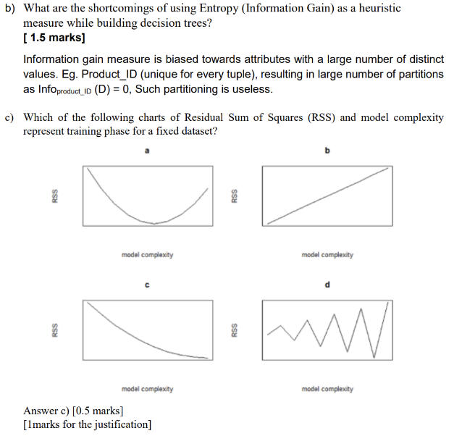
EndSem 2023-24 Regular

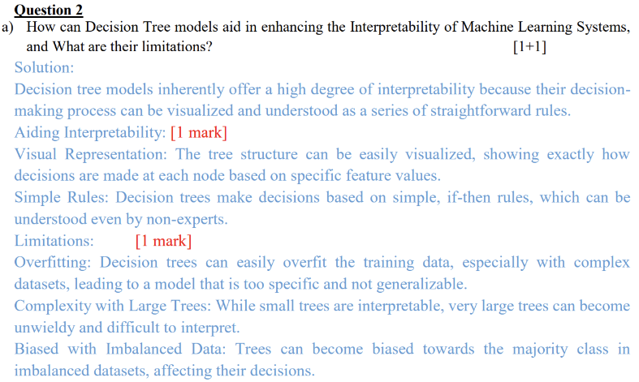

LECTURE - AdaBoost
EndSem 2022-23
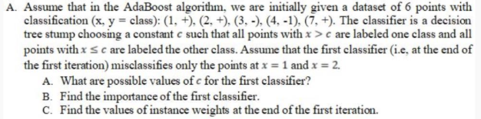

EndSem 2023-24 Makeup
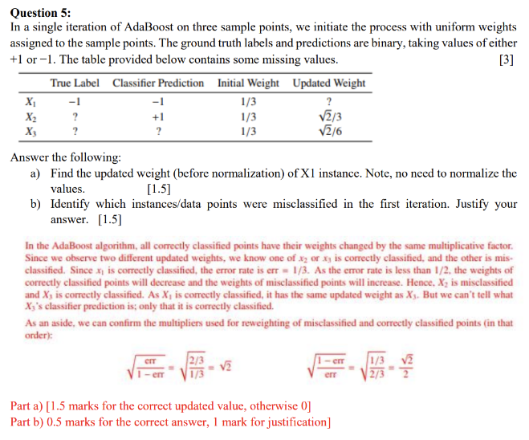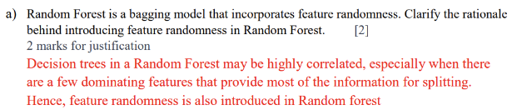
EndSem 2023-24 Regular
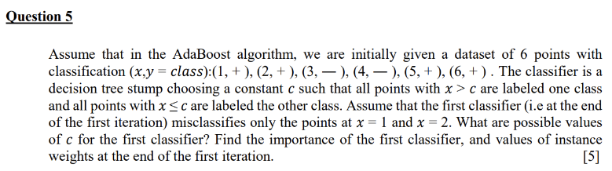
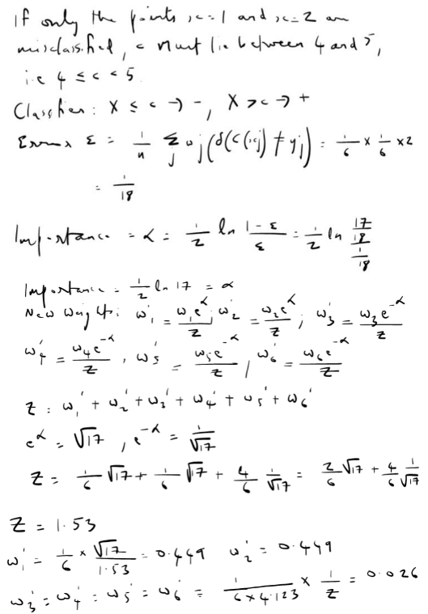
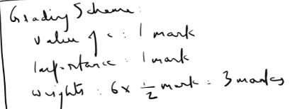
EndSem 2024-25 Regular
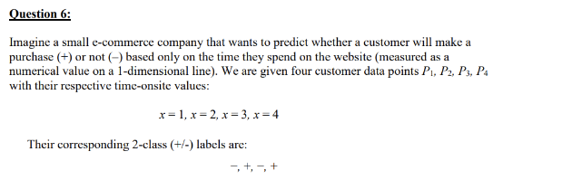
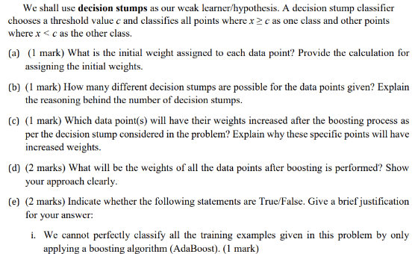

ii. The training error of a boosting classifier (combination of all weak classifiers)
monotonically decreases as the number of iterations in the boosting algorithm increases.
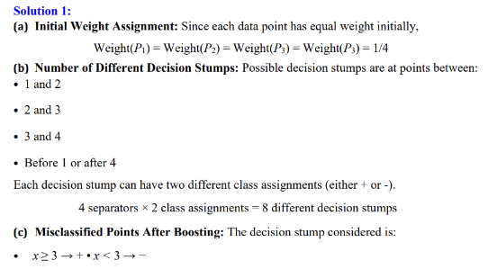
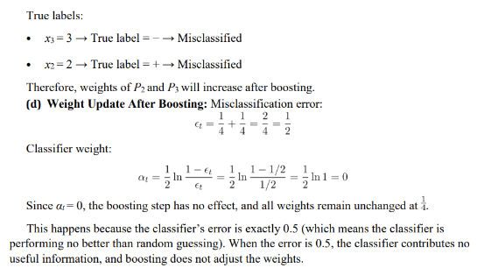
(e) True/False Statements:
i. True - Since the data is not linearly separable, boosting alone cannot perfectly classify the
data.
ii. False - Boosting minimizes the loss function:<sum i=1 to m e^(-yiF(xi)) which does not necessarily mean that the training error will decrease monotonically.

LECTURE - Support Vector Machine (SVM)
EndSem 2023-24 Makeup
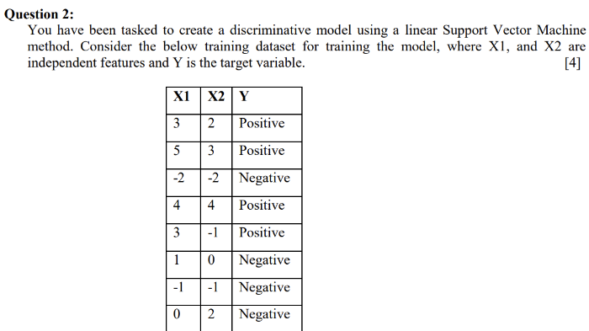
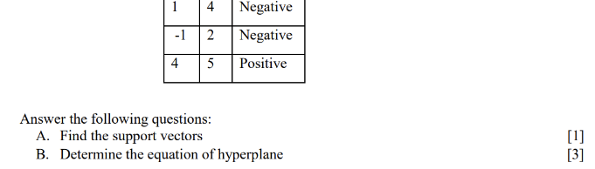
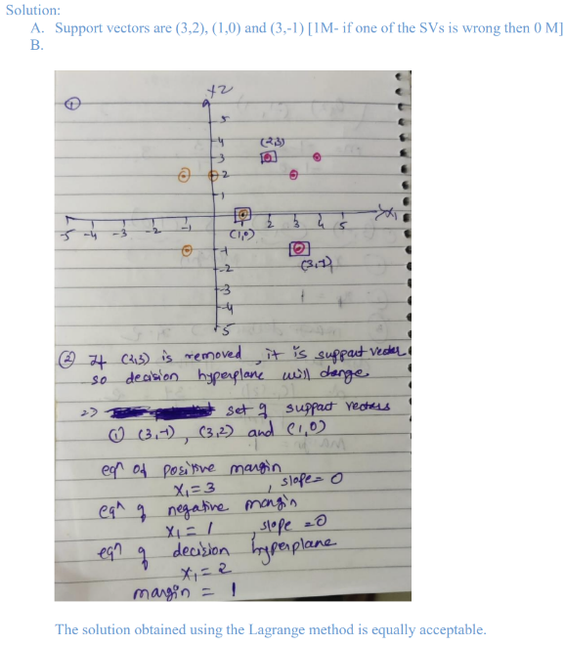
EndSem 2023-24 Regular
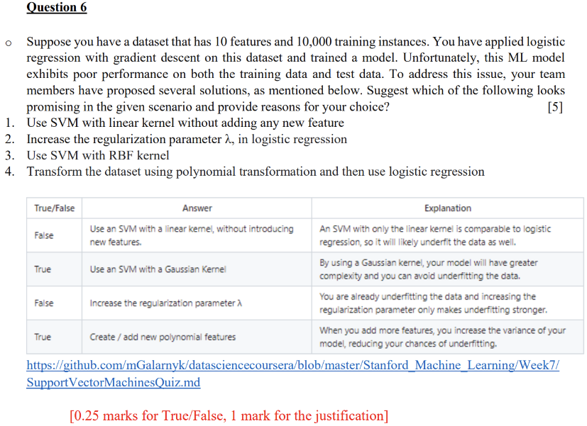

EndSem 2024-25 Makeup

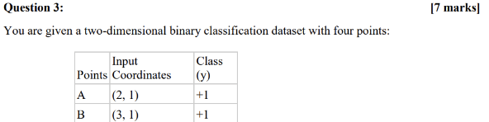
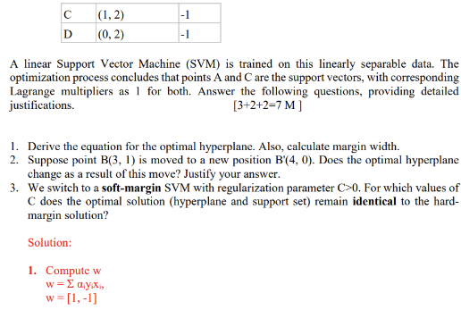
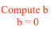
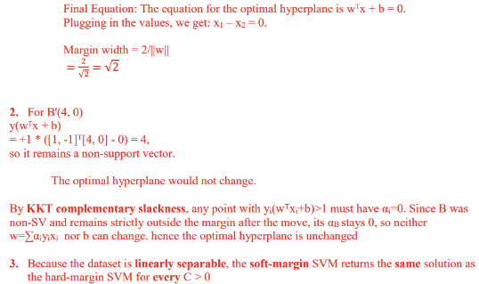
EndSem 2024-25 Regular

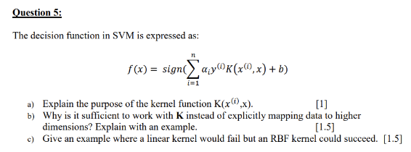
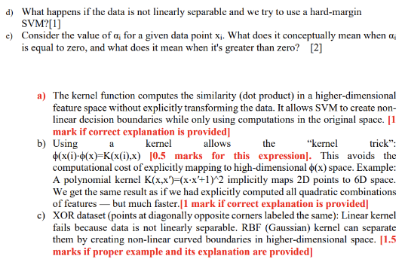
d) Hard-margin SVM requires perfect separation with no misclassifications. If data is
not linearly separable, the optimization will fail (no feasible solution) or overfit
drastically, because it cannot allow any margin violations. In such cases, a soft-
margin SVM with slack variables should be used. [1 mark]
e) ai=0: The point lies outside the margin and is not a support vector -> it does not
affect the decision boundary [1 mark]. ai>0: The point lies on the margin or is
misclassified -> it is a support vector and directly influences the decision boundary.
Larger ai indicates stronger influence on the position of the hyperplane. [1 mark]

LECTURE - unknown
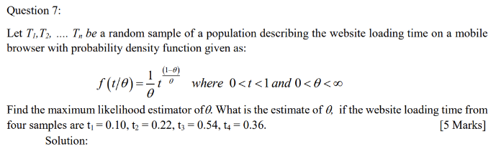
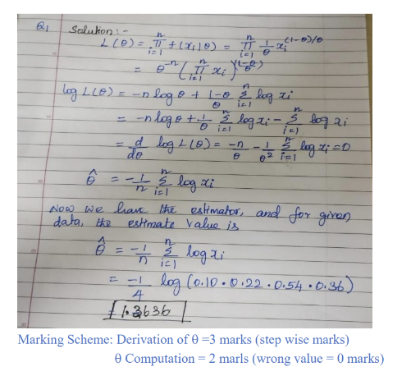
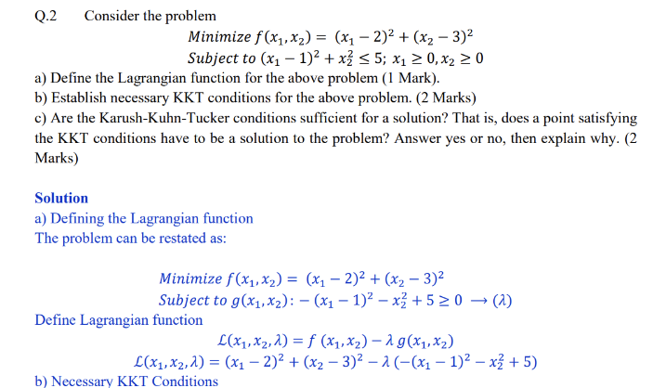
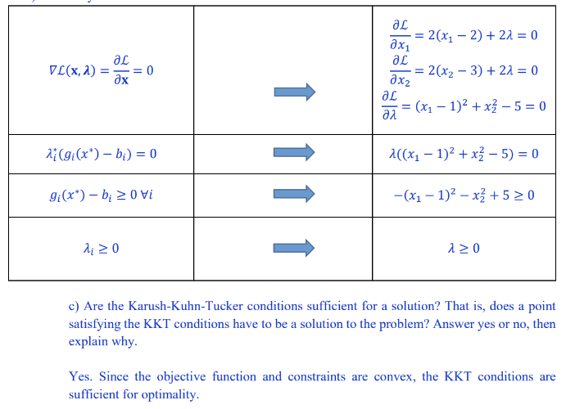
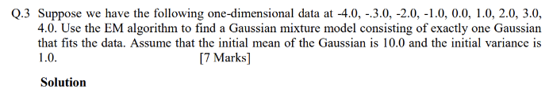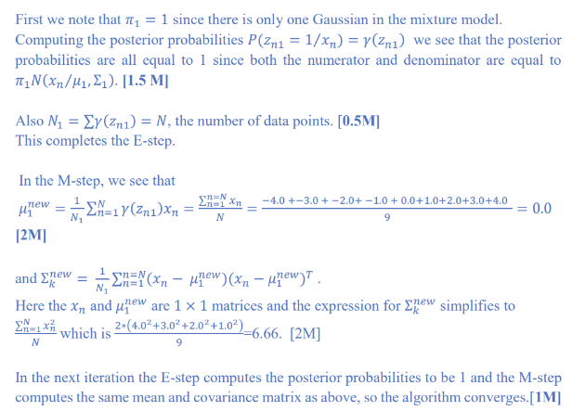
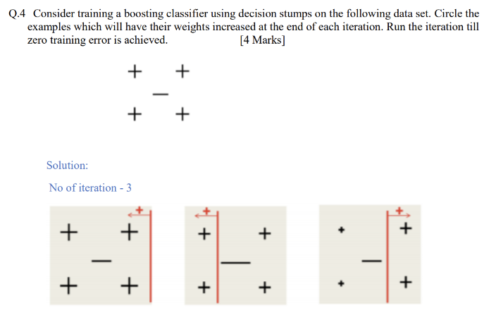

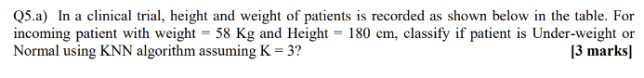
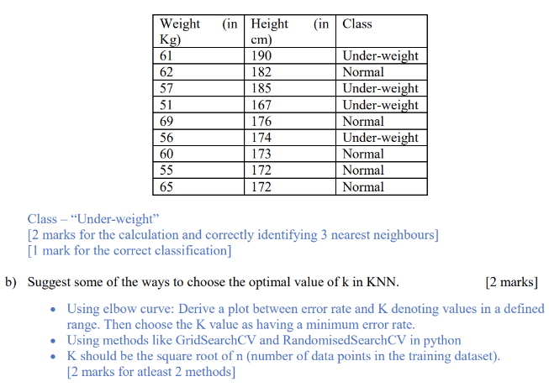
EndSem 2023-24 Makeup
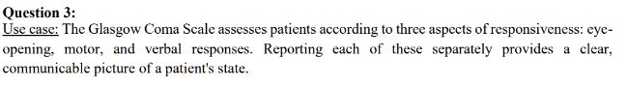
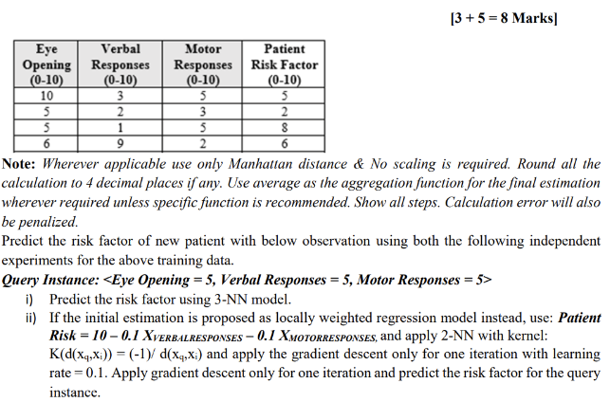
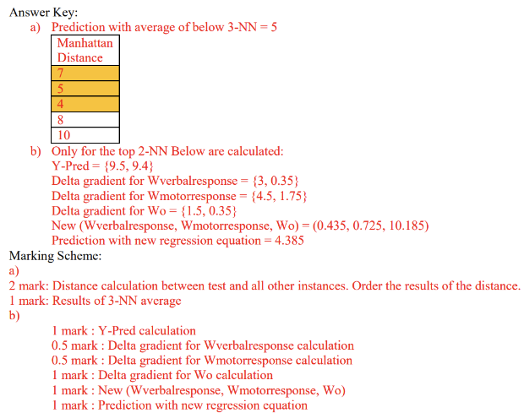
EndSem 2023-24 Makeup
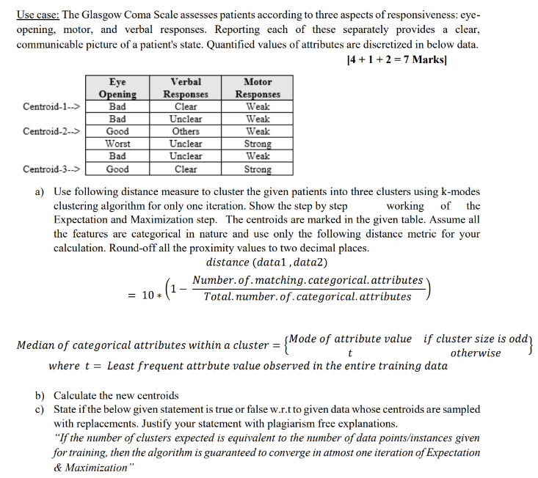
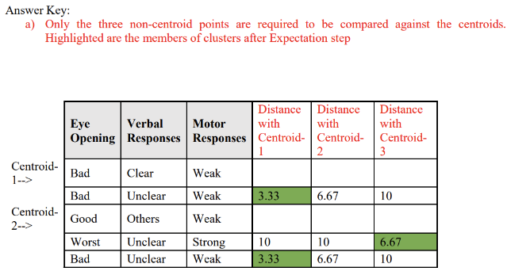
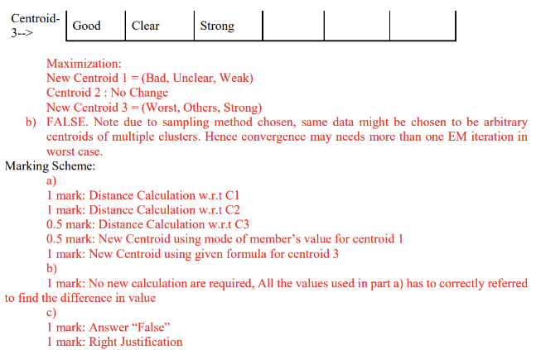
EndSem 2023-24 Makeup
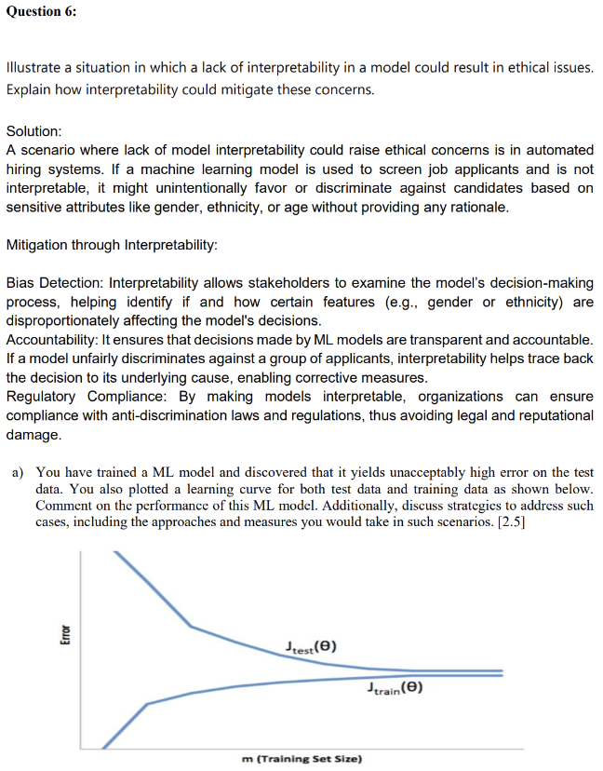
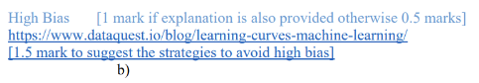
EndSem 2023-24 Regular
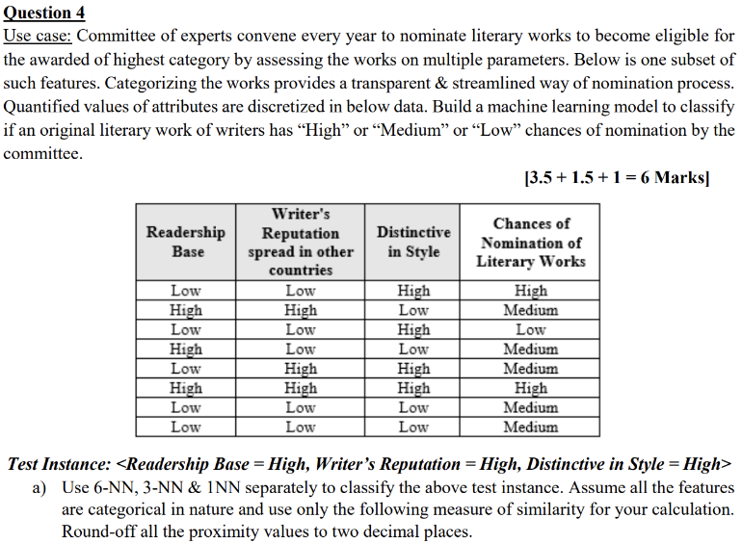
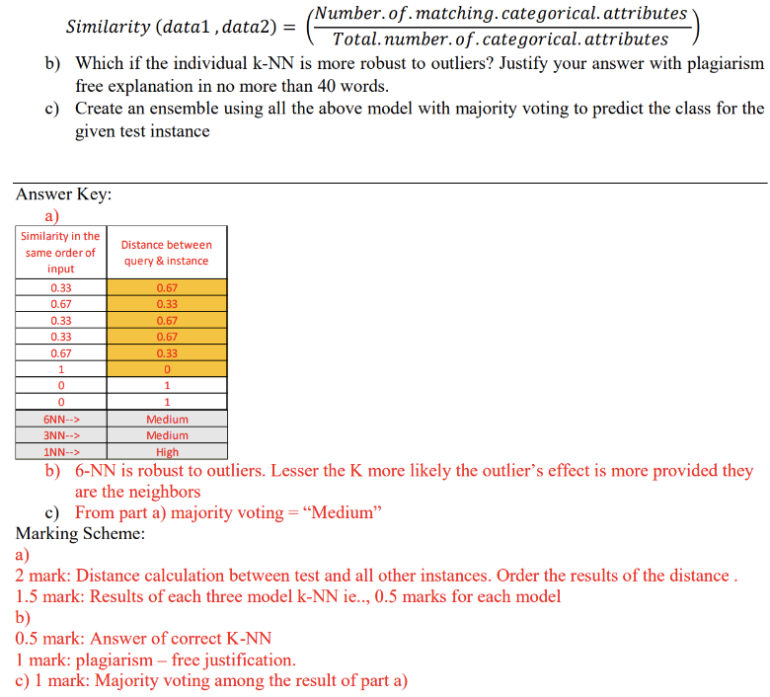
EndSem 2023-24 Regular
Question 5:
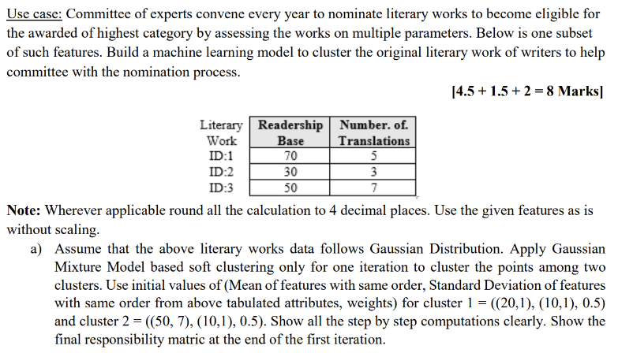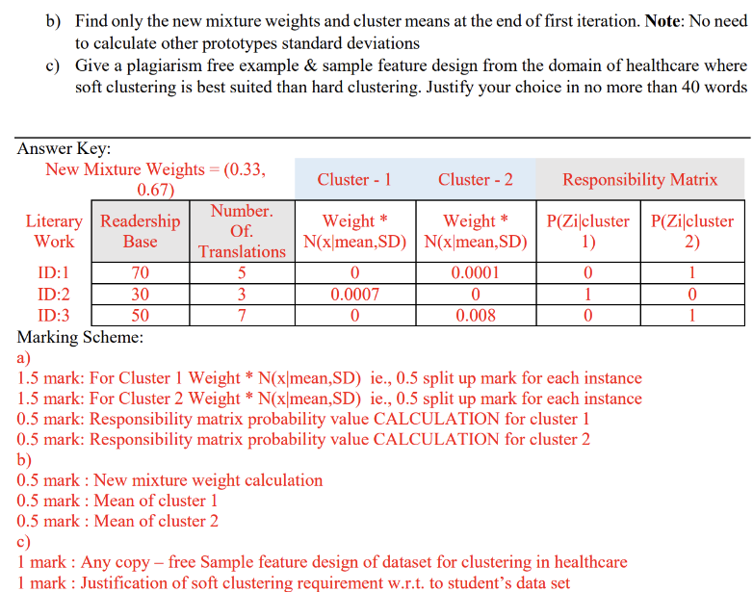

EndSem 2024-25 Makeup
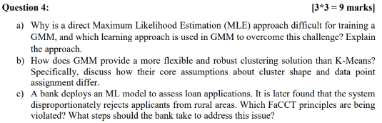
a) Direct Maximum Likelihood Estimation (MLE) for a Gaussian Mixture Model (GMM) is
difficult because the likelihood function is complex and lacks a closed-form solution.
Additionally, GMMs have latent variables-the unknown cluster assignments for each
data point. If we knew which cluster each data point belonged to, the problem would
simplify to fitting a separate Gaussian distribution to each cluster, which has a
straightforward MLE solution. However, since these assignments are hidden, we can't use
this direct approach. [1 mark]
The learning approach used to overcome this challenge is the Expectation-Maximization
(EM) algorithm. [1 mark]
[ 1 mark for explanation]
b) Think about "hard" vs. "soft" assignments and the underlying geometry of the clusters. K-
Means assumes spherical clusters of equal size, whereas GMM can model elliptical
clusters with varying sizes and orientations by using a covariance matrix.
c) Violated FaCCT Principles: Fairness, Accountability, Transparency
Steps the Bank Should Take:
. Bias Detection and Auditing,
· Data Rebalancing,
. Feature Review: Check for proxy variables (like location-based features) that might
indirectly encode bias and remove or adjust them if necessary.
. Algorithmic Fairness Techniques: Apply fairness constraints or post-processing methods
to reduce disparate impact.

EndSem 2024-25 Makeup
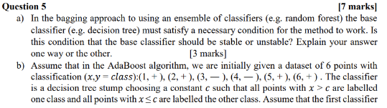
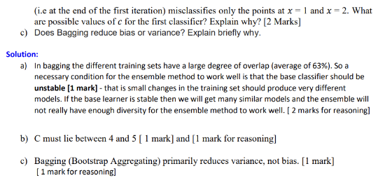

EndSem 2024-25 Regular
Question 1:
You are working on a text classification problem with 100,000 features (bag-of-words) and
5,000 training samples. You decide to use logistic regression with LI and L2 regularization. You
perform 5-fold cross-validation to select the regularization parameter A. The results are:
[4*1.5= 6 marks]
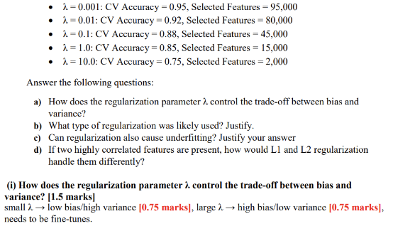
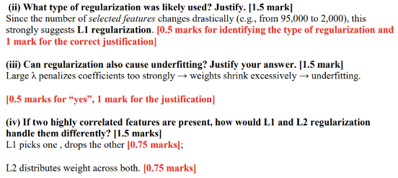

EndSem 2024-25 Regular
